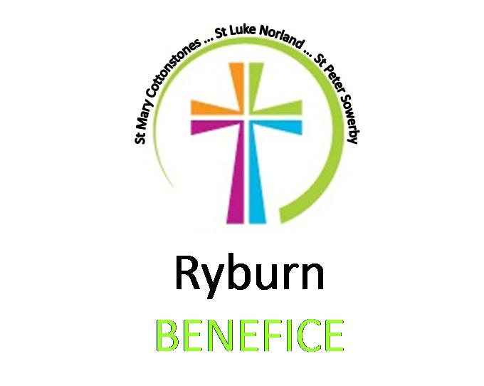

**Connected**



**The Churches of:**

**St Luke’s Norland**

**St Peter’s Sowerby**

**St Mary’s Cottonstones**

Church Contacts

|  |  |  |  |
| --- | --- | --- | --- |
|  | **Name** | **Telephone** | **Email** |
| **Vicar** | Revd Jeanette Roberts | 01422 646 371 | jeanette.roberts@leeds.anglican.org |
| Retired Priest &  Magazine Editor | Revd Lesley Ennis |  | lesleyennis@hotmail.co.uk |
| **St Mary’s, Cottonstones** | |  |  |
| Churchwardens | Jim Skelsey | 01422822936 | skelseyfamily@aol.com |
|  | Miriam Asquith | 01422 822534 | [miriam.asquith@hotmail.com](mailto:miriam.asquith@hotmail.com) |
| Verger | Contact Jim Skelsey |  |  |
| Organist | Bill Ellis |  |  |
| **St Mary’s Community Centre** | |  |  |
| Bookings | Jim Skelsey | 01422822936 | skelseyfamily@aol.com |
| **St Luke’s, Norland** | |  |  |
| Churchwardens | Jen Hallos | 01422 832700 | Jenhallos2@gmail.com |
|  | Lynne Wheale | 01422 834993 | lynnewheale@hotmail.co.uk |
| Verger | Contact Churchwardens |  |  |
| Organist | John Naylor | 07977846285 | john.r.naylor@live.com |
| **St Peter ‘s Sowerby** | |  |  |
| Churchwardens | Ken Cuttle | 01422 836487 | [kencuttle@aol.com](mailto:kencuttle@aol.com" \t "_blank) |
|  | Helen Gleave | 07735537364 | [helengleave@talktalk.net](mailto:helengleave@talktalk.net) |
| Verger | Contact Ken Cuttle |  |  |
| Organist | Richard Barnes | 01422 346215 |  |
| **St Peter’s Community Centre, Sowerby HX6 1HB** | | |  |
| Bookings | Ken Cuttle | 01422 836487 | [kencuttle@aol.com](mailto:kencuttle@aol.com) |

**Church Services**

**Sunday worship services in our Churches have resumed, subject to the latest Covid-19 recommendations regarding the wearing of a mask, observing social distancing; handwashing on entering and leaving the building etc.**

Revd Jeanette will be on sabbatical **from 5th April to 16th July.** During this time the church wardens will be the primary contacts in their respective churches. Please hold Revd Jeanette, Julie and Dylan in your prayers during this time, and also those who are kindly helping out by leading our services during this period.

Don’t forget to look us up on the web & Facebook

[**www.ryburnbenefice**](http://www.ryburnbenefice)**.org**

*Vicar: Revd Jeanette Roberts tel 01422 646 371* [*jeanette.roberts@leeds.anglican.org*](mailto:jeanette.roberts@leeds.anglican.org)

*######################################################*

## Interesting Quotes

Jesus didn’t commit the gospel to an advertising agency; He commissioned disciples. – Joseph Bayly

Nothing is ever lost by courtesy. It is the cheapest of pleasures; costs nothing and conveys much. – Erastus Wiman

# The Parable of the Great Banquet

*Canon Paul Hardingham considers our priorities in life.*

One thing that we’ve probably missed over the past year is parties. Well, this month should enable us to party again! Lots of Jesus’ parables focus on parties, as they are a picture of the joy, hope and life of the kingdom of God. The parable of the Great Banquet (Luke 14: 15-24) challenges us not to miss out on this.

In Jesus’ day, when people accepted an *invitation* to a banquet, they were only told the actual time on the day: *‘Come, for everything is now ready’* (17). Jesus’ invites each one of us to share in the life of His kingdom.

However, the guests made *excuses* for not coming. At the time, this would have been extremely insulting to the host. They said: *‘I have just bought a field; I must try out my new team of oxen; I have just got married’* (18-20). These are all good things in themselves, however they reveal their priorities were elsewhere.

We too can be pre-occupied with our own routines of work, family, retirement, holidays, friends, home, social media, that we forget God’s priorities for our lives. Jesus calls for total commitment from His disciples. *What priority in my life is holding me back from accepting His invitation?*

How did the host *respond*? He ordered His servants to *‘Go out quickly into the streets and alleys of the town and bring in the poor, the crippled, the blind and the lame.’* (21). He invited the unexpected and unacceptable people to His banquet. Jesus makes the point that *God’s kingdom is open to all*! Thinking about our family, friends, colleagues and neighbours, even if they’re not like us or show little interest in God: *Are we willing to offer them God’s invitation to share His love and life?*

Archbishop of York’s Presidential Address to General Synod    
It was “sobering and shameful” for the Church of England to be “confronted by the recent Panorama documentary”, which looked at “a number of shockingly specific instances where sisters and brothers in Christ have experienced racism in the Church of England.”

So said the Archbishop of York in his recent Presidential Address to the General Synod.

He went on to say that the Anti-Racism Task Force set up by the Church last autumn had now published its “inspiring, challenging, and – God willing – far reaching report” to deal with the “institutional racism” found in the church.

“It identifies five areas where urgent action is needed, namely: participation, including appointments and shortlists for appointments; education; training and mentoring; work with young people; and governance and structures.”

The Archbishop looked forward to the discussion of all this at a future Synod. “However, we couldn’t let this group of sessions pass without acknowledging the scale of the challenge and the call to action.”

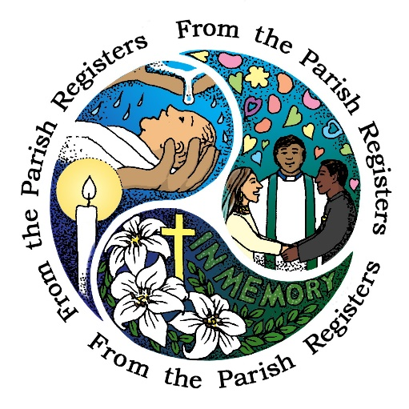The Archbishop went on: “I’m not standing here to defend our record. Nor am I saying everything will be ok. …I’m saying that there is racism in the Church, and it must be confronted.”

The Archbishop agreed with a statement by the Revd Arun Arora which said: ‘Apologies and lament must now be accompanied by swift actions leading to real change.’

# ****Keeping faith in the local media****

Revd Peter Crumpler is all for working with our local media.

The vital role played by local newspapers and radio in encouraging greater understanding of faith has been highlighted in a newly-published parliamentary report.

I say Amen to that.

‘Learning to Listen’, produced by the All-Party Parliamentary Group on Religion in the Media, praises the positive role played by local and regional media in reporting religion in a “balanced, nuanced and informative way.” It forms part of a wide-ranging review of ‘religious literacy’ across the press and broadcasting.

The report contrasts this sensitive grassroots coverage with the way faith is often reported in the national press.

As someone who trained as a local newspaper reporter and has been involved in working with the media to cover faith issues for more than 45 years, I wholeheartedly agree with the report’s praise.

But from conversations with editors and faith leaders, I know there still exists a divide to be crossed. Often, local journalists are unaware of the rich source of news and feature stories that lie within local faith communities.

And the vicars, pastors, rabbis, imams and other faith leaders are either wary of their local media or are not aware that the local newspaper or radio station would welcome hearing from them.

Where churches and other faith groups have built links with their local media, positive, informed coverage is often achieved.

In the 98-page ‘Learning to Listen’ report, the group of MPs and members of the House of Lords said, “We heard compelling evidence that local media continues to represent religions in a more balanced, nuanced and informative way than national media.

“Reporting on local religious festivals, community events and local charities can represent the lively reality of religious practice and experience in a way that is very difficult for national journalism to achieve.”

The parliamentarians also praised the role of BBC local radio in reporting faith, stating “regional broadcasting has an important role to play in representing everyday belief. It has the capacity to introduce new perspectives at the same time as creating a common narrative. It is an area where religious programming continues to be valued and prioritised.”

The report highlights the Sunday morning faith and ethics-based programmes broadcast by English BBC local radio stations, and comments “when prioritised, good local religious programming can be engaging, interrogative and enjoyable.” It commends especially the role played by the stations in covering faith issues during the pandemic.

But the parliamentary report also spells out the challenges to local reporting. Advertising has been sucked away from regional and local newspapers by the social media giants, and BBC local radio is under pressure as the Corporation’s licence-based funding comes under attack.

In response to these challenges the report concludes, “This loss of local, public interest reporting is deeply worrying. Not only does local journalism play an important social and democratic role, we received compelling evidence that it fulfils a valuable function in representing religion and belief in an accessible and balanced way.

By The Revd Peter Crumpler, a Church of England priest in St Albans, Herts, and a former communications director for the CofE,

# Reflected Faith: Sit and be Still

*The Revd Dr Jo White continues her Reflected Faith series with what it can really mean to ‘be still.’*

How do you ‘sit’ in church? I’m a wriggler and change my position on the seat often. I cross one leg over the other, then swap them over, stretch them out, then cross them at the ankles. I do the same with my arms.  I lean one way and then the other.

In other words, ‘I’m a fidget.’ But having been absent from a church building for so long, I wanted to think this month about simply *sitting and being still* before the Lord.

I’m well aware we’ve done little else this last 18 months – but if you manage to get into a church building, for whatever reason I’d like to encourage us all to just sit still and breathe in the place. To relish being ‘back’!

To sit ‘heavily’ in that spot. To feel the solidity of the surface you are sitting on.  Lean into it.  Feel how it supports you.  Feel each part of your body where it is touching the chair or pew.

Look around you at all the distinctive seating set aside for the different participants of the church: the choir, the worship leader, a deacon or curate, the priest and so on.

In an Anglican church there will be a chair especially dedicated for the use of the Bishop.

However plain or fancy each piece of furniture is within your building, they all have the same purpose.  To hold the person and keep them safe.

*This month:*

As you sit in the church building – or at home if you are not able to do so – think of all those people in the Bible stories who sat with Jesus. The number of times He taught in the Temple or in a synagogue, or to crowds gathered on a hill. Recall the Last Supper and His friends gathered sitting with Him to eat and share the Passover meal, and then recall the meal with the men from the Emmaus Road. So many meal times with the bold and the weak, the saints and the sinners. With you and me.

 #########################################################

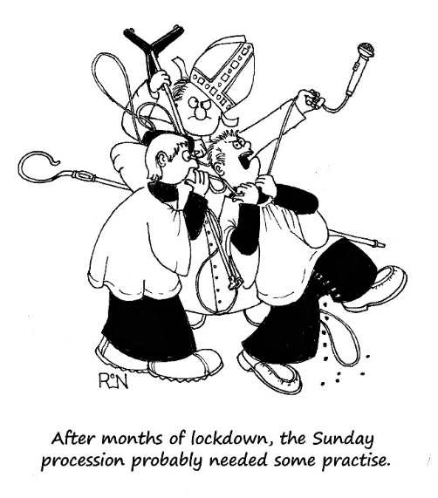

**Hello God …**

**Prayer for Encouragement in June**

Father,

At this time of year, we remember Barnabas, a good man, full of the Holy Spirit and faith, who encouraged people to stay true to you – and others to trust you for the first time.

Lord, we have gone through difficult days. The pandemic has taught us that we are not in control. We don’t know what each new day might bring. As we move into June and the hope of more normality after the restrictions of Lockdown, we too need encouragement.

Help us to have courage to step forward with confidence and common sense. Most of all help us to stay true to you and to trust you, knowing that you are the security we need, knowing that you will never leave us or forsake us. Help us to be en-couraged!

In Jesus name, Amen.

By Daphne Kitching

# ****Peace between neighbours****

Peace between neighbours near,  
Peace between kindred here,  
Peace between lovers dear,  
In the love of the King of us all.

Peace man with man abide,  
Peace man to wife allied,

Mother and bairns to guide,  
And peace of the Christ above all.

Bless, O Christ, bless my face,  
My face bless every face,  
Christ, bless mine eye with grace,  
Mine eye give a blessing to all

From Poems of the Western Highlanders

**Belief**

Our elderly vicar was very devout, but sometimes lost his place during the service.  One Sunday as we reached the Creed there was a long silence, so the curate went across to him and gently touched his arm.  “I believe in God,” she whispered.

The vicar smiled back happily. “Oh so do I, so do I!”

######################################################

**Wake up!**

Remember the story of Jacob, and how God met him in a dream when he was sleeping on the desert floor with a rock for his pillow? The story in Genesis 28 says this: ‘When Jacob awoke from his sleep, he thought, “Surely the Lord is in this place, and I was not aware of it.”’

I wonder what place you find yourself in today, and if you are aware of God’s presence with you there?

It may be a geographical place, the place where you live or work. That may be a beautiful place to be, or it may be a very hard place to be, and you would much prefer to be somewhere else. Either way, God is with you there, for He is everywhere, and there is no place where He is not.

It may be an emotional place, as when we say, ‘I’m not in a good place right now’. How are you feeling today – up or down? Again, whatever mood you are in, God is with you for He knows us through and through. Having become human, He understands all our fluctuating emotions. He can comfort us right where we are.

It may be a phase of life that you are passing through, a stage on life’s journey or a transition as you move from one situation to another. You may be passing through the valley of grief and loneliness, or anxiously waiting for news of a loved one who is ill. No matter where you are, you are not alone, for God is with you whether you can feel His presence or not.

What is needed is for us to become more aware of God’s surrounding presence, to wake up to His closeness as did Jacob.

**Old and alone and needing help…**

An old Italian priest lived alone. He wanted to plant his annual tomato garden, but it was very difficult work, as the ground was so hard.  A member of his church, Vincent, who used to help him, was in prison. So the old priest wrote a letter to his parishioner and described his predicament:

Dear Vincent, I am feeling pretty sad because it looks like I won’t be able to plant my tomato garden this year. I’m just getting too old to be digging up a garden plot. I know if you were here my troubles would be over. I know you would be happy to dig the plot for me, like in the old days. I remember you in my prayers.  
Fr Louis

A few days later he received a letter from his parishioner.

Dear Fr Louis, whatever you do, don’t dig up that garden. That’s where the bodies are buried. Thanks for your prayers.Vinnie

At 4 am the next morning, the local police arrived and dug up the entire area, without finding any bodies. They apologised to the old priest and left. That same day the old priest received another letter.

Dear Fr Louis, you can go ahead and plant your tomatoes now. That’s the best I could do under the circumstances.Vinnie

# First, you simply have to be willing to listen

*Editor: This is adapted from an article by Matt Jolley of the London Institute for Contemporary Christianity (LICC).*

*… the sheep listen to his voice. He calls his own sheep by name and leads them out. …he goes on ahead of them, and his sheep follow him because they know his voice. (John 10:3-4)*

*Therefore, everyone who hears these words of mine and puts them into practice is like a wise man who built his house on the rock. (Matthew 7:27)*

“Bad listeners do not make good disciples.” So said the well-known Christian writer John Stott, whose centenary we celebrate this year. And Stott’s ‘listening ear’ still remains at the heart of what disciples are called upon to do, today.

We listen to God because God speaks, and He speaks to us primarily through Scripture. Through the Spirit’s animation, these ancient scrolls remain living and active, addressing our contemporary world. Listening to this living Word is to receive life itself; to ignore it leads to death.

##########################################################

# **Bishop tells General Synod to speak against persecution of religious believers and atheists**

The Bishop of Leeds, Nick Baines, recently told General Synod that “human dignity and flourishing is diminished” when religious believers and atheists are persecuted.  
  
He also warned the Church of England’s decision-making body that it would be an “act of self-harm” only to speak up for persecuted Christians.  
  
Speaking in a debate on Freedom of Religion or Belief (FoRB), Bishop Nick addressed many abuses including against Uighur Muslims in Xinjiang, China, atheists in Saudi Arabia, and Christians in Pakistan.  
  
"If human rights mean anything, then the freedom to choose our religion or belief, the freedom to change our religion or belief and the freedom to have no religion or stated belief at all is a right we all have by virtue of being human," Bishop Nick said.  
  
He continued: “Violations are increasing and intensifying involving not just intolerance and exclusion but active discrimination.  
  
“In its ultimate form this can culminate in genocide, a phenomenon that has sadly been seen with increasing frequency, whether that of Christians and Yazidis at the hands of Isis in Iraq, Rohingya Muslims in Myanmar or Uighurs in China.”  
#############################################################

**The man who invented the saxophone**

It was 175 years ago, on 28th June 1846, that Belgian musical instrument maker Adolphe Sax patented the saxophone. Born Antoine-Joseph in 1814, Sax quickly became known for his brilliant inventiveness and his abrasive personality, but also – to the despair of his mother – for his brushes with death as a child.

He fell from a height of three floors and was believed dead, drank a bowl of dilute sulphuric acid thinking it was milk, swallowed a pin, and received serious burns from a gunpowder explosion. He also fell on to a hot cast-iron frying pan, was struck by a cobblestone and fell into a river, then several times narrowly escaped poisoning from sleeping in a room where varnished furniture was drying.He also contracted lip cancer in the 1850s but made a full recovery.

It was surprising then, that he lived until his 80th year, dying in poverty in Paris despite his many musical instrument inventions, which did not bring him wealth because they were copied by others, despite his patent.

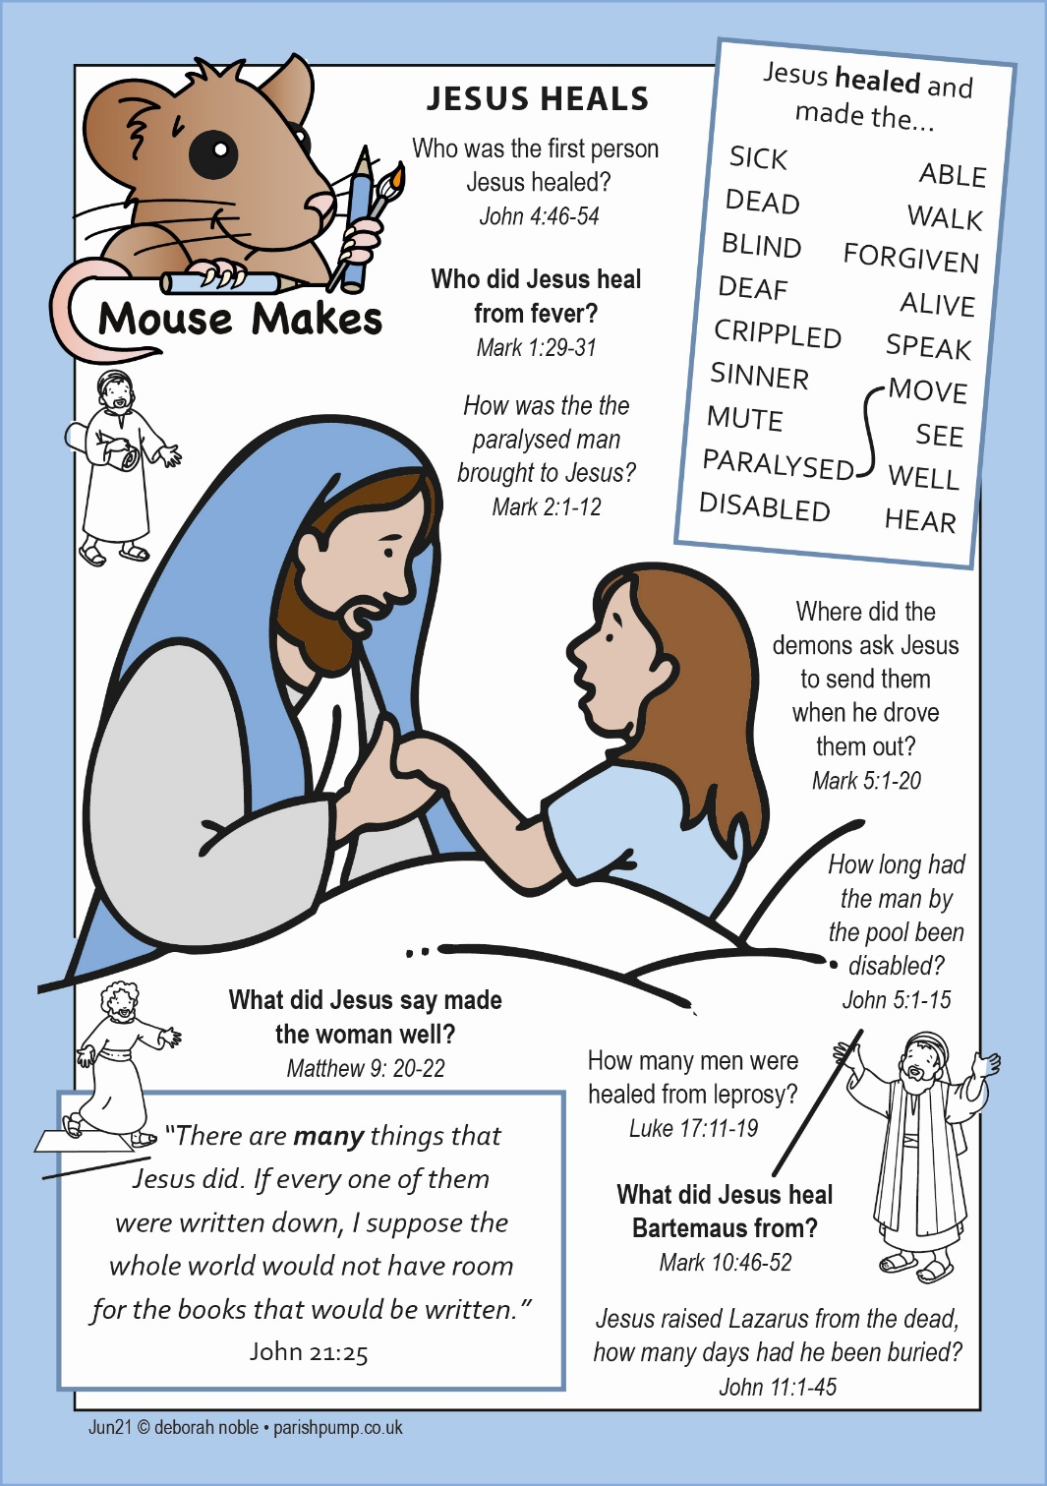

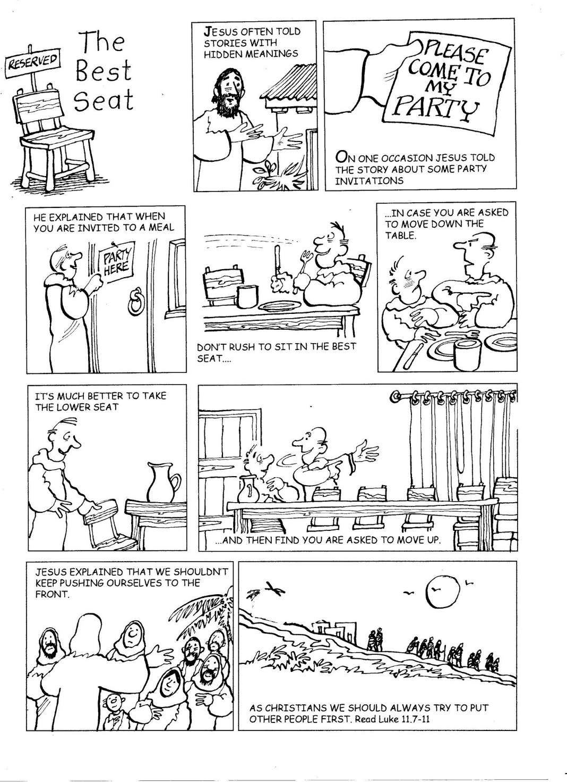

*Here is an opportunity if anyone wants to get involved locally …..*

**Churches to launch nature count within the ‘National Park’ of churchyards**

Hundreds of churches have signed up to a week-long ‘nature count’ occurring this month (June), which will encourage people to visit churchyards and record what they see.

Churches Count on Nature, to run between 5th-13th June, is a citizen-science event covering churchyards across England and Wales.

Communities and visitors will be asked to make a note of the animals, birds, insects, or fungi in their local churchyard. Their data will then be collated on the [National Biodiversity Network](https://burialgrounds.nbnatlas.org/).

It is being jointly run by the conservation charities Caring for God’s Acre, A Rocha UK, the Church of England, and the Church in Wales.

Church land, often uniquely unploughed and undeveloped, can be a habitat for precious, endangered plants and wildlife. Together, churchyards cover a huge area –estimated to be equivalent to a small national park.

The week is open to anyone with a love of nature, and churches are seeking links with local schools and local wildlife groups.

Various online guidance about getting to know fauna and flora is being shared with the churches who are participating. A similar national event [Love Your Burial Ground Week](https://www.caringforgodsacre.org.uk/about-us/calendar/love-your-burial-ground-week/) will be combined with this project.

Registration for the webinars is on the [Church of England’s website](https://www.churchofengland.org/about/environment-and-climate-change/webinars-land-and-nature-churches-count-nature-week) and also at [Churches Count on Nature online](https://www.caringforgodsacre.org.uk/expression-of-interest-in-churches-count-on-nature-2021/churches-count-on-nature-faqs/).

*\*\*\*\*\*\*\*\*\*\*\*\*\*\*\*\*\*\*\*\*\*\*\*\*\*\*\*\*\*\*\*\*\*\*\*\*\*\*\*\*\*\*\*\*\*\*\*\*\*\*\*\**

**Thankful**  
A minister said to a precocious six-year-old boy, "So your mother says a prayer over you each night? That's very commendable. What does she say?"

The little boy replied, "Thank God he's in bed!"

**Crossword clues (June 2021)**

(The Crossword solution is found on page 22)

**Across**

1 Military tactic used by Joshua to attack and destroy the city of Ai (Joshua 8:2) (6)

4 Place of learning (6)

8 ‘When Moses’ hands grew — , they took a stone and put it under him and he sat on it’ (Exodus 17:12) (5)

9 Unpleasant auguries of the end of the age, as forecast by Jesus (Matthew 24:7) (7)

10 Stronghold to which girls in King Xerxes’ harem (including Esther) were taken (Esther 2:8) (7)

11 Where Saul went to consult a medium before fighting the Philistines (1 Samuel 28:7) (5)

12 Propitiation (Hebrews 2:17) (9)

17 Turn away (Jeremiah 11:15) (5)

19 So clear (anag.) (7)

21 ‘I have just got — , so I can’t come’: one excuse to be absent from the great banquet (Luke 14:20) (7)

22 Long weapon with a pointed head used by horsemen (Job 39:23) (5)

23 Musical beat (6)

24 What the Israelites were told to use to daub blood on their door-frames at the first Passover (Exodus 12:22) (6)

**Down**

1 Fasten (Exodus 28:37) (6)

2 Art bite (anag.) (7)

3 ‘The people of the city were divided; some — with the Jews, others with the apostles’ (Acts 14:4) (5)

5 Contend (Jeremiah 12:5) (7)

6 Possessed (Job 1:3) (5)

7 Sheen (Lamentations 4:1) (6)

9 ‘You love evil rather than good, — rather than speaking the truth’ (Psalm 52:3) (9)

13 Large flightless bird (Job 39:13) (7)

14 They were worth several hundred pounds each (Matthew 25:15) (7)

15 ‘A — went out to sow his seed’ (Matthew 13:3) (6)

16 How Jesus described Jairus’s daughter when he went into the room where she lay (Mark 5:39) (6)

18 The part of the day when the women went to the tomb on the first Easter morning (John 20:1) (5)

20 Narrow passageway between buildings (Luke 14:21) (5)

###############################################################

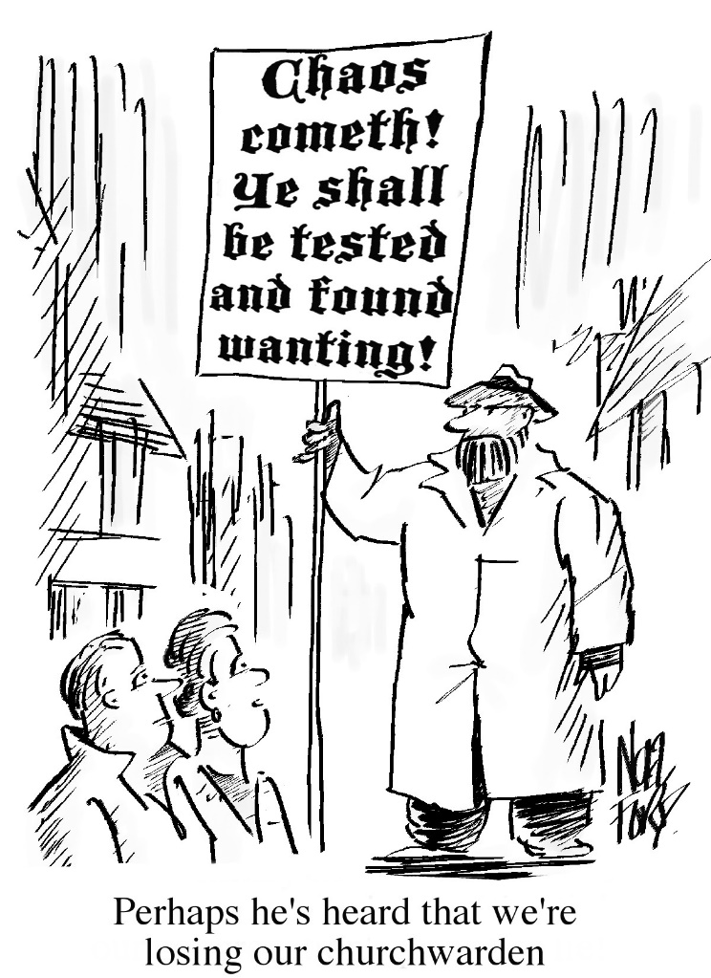

**Many Churches have stepped up support for their communities during pandemic**

More than 4,000 Church of England parishes have stepped up their support to local communities in the face of rising levels of poverty, loneliness and isolation since the Covid-19 pandemic, according to new research.

Church volunteers have delivered food, shopped, walked dogs and collected prescriptions this past year, according to a report by the Church of England and Church Urban Fund.  
Church volunteers have also done gardening projects, been ‘phone buddies’, aided with job-hunting, and helped people get online, as local people struggled with the social and economic effects of the pandemic.  
Despite restrictions on meeting socially, nearly a quarter of churches even started a completely new activity during the pandemic. More than of them adapted two or more of their existing community activities in order to meet local needs.  
Overall, 37% of churches reported that they were providing *more* support to their communities, with this figure rising to 41% in rural areas.  
Food provision and pastoral support were by far the biggest area of support provided by churches, with nearly 80% of churches involved in running or supporting a food bank or similar service. Many opened food banks for the first time.  
Church leaders reported that isolation, loneliness and mental health difficulties, food poverty, unemployment and debt are more widespread in their communities as a result of the pandemic.   
Church buildings, because of their size and ventilation, have been well used for activities from ante natal classes to socially prescribed exercise. In fact, many became ‘symbols of hope’, with flags, posters and artwork as a “form of visual encouragement”.  
Church Urban Fund Chief Executive Rachel Whittington said: “2020 was a year like no other, and yet churches across the UK rose … with undeterred compassion, displaying the love in action which lies at the heart of the Christian gospel.”

# The story behind the HYMN: ‘Lord, for the years’

*Editor: We present here some of the lyrics of the hymn… the full lyrics may be found on the internet.*

*Lord, for the years your love has kept and guided,  
urged and inspired us, cheered us on our way,  
sought us and saved us, pardoned and provided:  
Lord for the years, we bring our thanks today.  
  
Lord, for that word, the word of life which fires us,  
speaks to our hearts and sets our souls ablaze,  
teaches and trains, rebukes us and inspires us:  
Lord of the word, receive your people's praise.  
  
\*Lord, for our hopes, the dreams of all our living,*

*Christ and his kingdom one united aim;*

*Rulers and peoples bound in high thanksgiving,*

*Lord of our hopes, our trust is in your Name. …*

*By Timothy Dudley Smith*

This well-loved hymn was written in 1967 by the Revd Timothy Dudley Smith, who later became Bishop of Thetford. He later confessed: “I wrote it on a train when I was very pressed for time. I’m thankful if something I write gets picked up, but I suspect anyone who does something in a rush later regrets that they didn’t find time to apply the sandpaper a bit more!”

Dudley Smith had been asked to write a hymn for the centenary service of the Children’s Special Service Mission, now Scripture Union, in St Paul’s Cathedral. His commission was to write words that could be fitted to Jean Sibelius’s *Finlandia*, as it was to be accompanied by an orchestra with this tune in their repertoire. And so – ‘Lord for the years’ was written.

Dudley Smith need not have worried about lack of time – his lyrics were a ‘hit’ in the cathedral on the day, and went on to become so well-loved that George Carey chose the hymn to be sung at his consecration as Bishop of Bath and Wells, and then again later, in 1991, or his consecration as Archbishop in Canterbury Cathedral.

The hymn continued to be widely sung and loved, until in 2002 Timothy Dudley Smith was asked to write an extra verse for it so that it could even be sung around the time of the Queen’s Golden Jubilee.

Many of the words in the hymn are true for the Queen herself, as she celebrates her 95th birthday this month. She does indeed thank God ‘for the years your love has kept and guided, urged and inspired us, cheered us on our way’…

And so indeed the ‘extra’ verse added for the Queen has also held true:

*Lord for our hopes, the dreams of all our living,*

*Christ and his kingdom one united aim,*

*Rulers and peoples bound in high thanksgiving,*

*Lord of our hopes, our trust is in your Name.*



We take this opportunity to wish a Happy Birthday to Her majesty Queen Elizabeth ll on June 21st

# Don’t make decisions on an empty stomach.

Scientists at Harvard have found that when you have higher levels of the body’s hunger hormone, ghrelin, in your system, you are more likely to be impulsive. This means that you will be liable to make poor decisions, tending towards instant gratification rather than long-term achievement.

In one experiment, hungry women with a higher amount of the hunger hormone chose to receive £20 the same day, instead of £80 in two weeks’ time.

So, ghrelin may well “play a broader role in human related behaviour and decision making, such as monetary choices.”

# Trouble sleeping?

Try listening to ‘sedative music’, with a slow tempo, soft volume and smooth melody. Music is less invasive than sleeping pills, and may possibly work for you.

A recent study carried out at a university in Taiwan found that “listening to sedative music can improve sleep by modulating sympathetic nervous system activity and the release of cortisol, thereby lowering levels of anxiety and stress responses.”

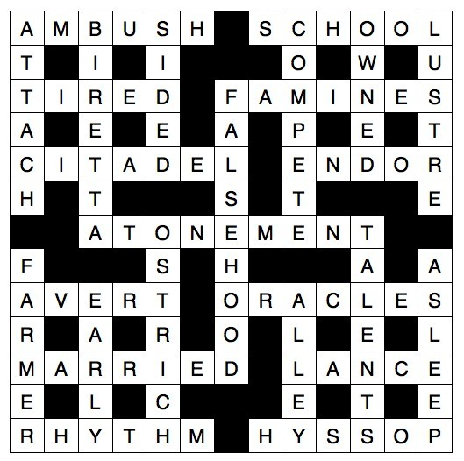Listening to music before bed for more than four weeks was found to be especially effective.

\*\*\*\*\*\*\*\*\*\*\*\*\*\*\*\*

Crossword Solution

June 2021

# Give a compliment

*Editor: By Colin Hammacott*

We all like to receive a compliment from time to time. As Robert Orben, former script writer for President Gerald R. Ford once said, “A compliment is verbal sunshine.”

Another American, Leo Buscaglia once observed: “Too often we underestimate the power of a touch, a smile, a kind word, a listening ear, an honest compliment, or the smallest act of caring, all of which have the potential to turn someone’s life around.”

At a funeral service, nice things are usually said of the deceased. While these comments are comforting for the relatives, did the same folks ever bother to say these kind things to the person themselves, when they were alive, to show them how much they were appreciated?

Sadly, not everyone seems able to compliment others. Perhaps they never received compliments when they were young, or perhaps they feel that to compliment someone else is to somehow put themselves down. For whatever reason, such people miss out on a whole lot of pleasure in life.

Whenever we see something that is worthy of a compliment, why not give it, and bring ‘a little verbal sunshine’ into someone else’s life!

\*\*\*\*\*\*\*\*\*\*\*\*\*\*\*\*\*\*\*\*\*\*\*\*\*\*\*\*\*\*\*\*\*\*\*\*\*\*\*\*\*\*\*\*\*\*\*\*\*\*\*\*\*\*\*\*\*\*\*\*\*\*\*

**Don’t forget the other half**  
When my daughter said her bedtime prayers, she would bless every family member, every friend, and every animal (current and past). Then one night, after we had finished the nightly prayer, she added: "And all girls." This soon became part of her nightly routine.

Finally, my curiosity got the best of me and I asked her why she had begun adding the part about all girls. Her response? "Because at church the minister only ever says ‘all men!’”

# Book Review …

**God's Brilliantly Big Creation Story**

**By Dai Woolridge, Bible Society, £6.99**

Here’s a good way to introduce young children (aged three to six) to the Genesis creation account. Written with rhythm and rhyme, the book covers the awe-inspiring journey through the days of Creation, and it is full of fun and beautiful imagery, from the vastness of the solar system to the immediacy of small animals.

The book would be good for reading aloud to preschool-aged children, and for use with children starting to learn to read. It will help parents looking for a fun, fresh way to introduce children to the Christian faith.

# God in the Arts

*The Revd Michael Burgess continues his series on God in the Arts with ‘Christ before the High Priest and the Denial of Peter’. This painting, done in tempera on wood, now hangs in the Museo dell'Opera del Duomo, Siena. Our picture of it is in the public domain, and can be found at:* [*https://upload.wikimedia.org/wikipedia/commons/d/de/Duccio\_di\_Buoninsegna\_-\_Christ\_before\_Annas\_and\_Peter\_Denying\_Jesus\_-\_WGA06796.jpg*](https://upload.wikimedia.org/wikipedia/commons/d/de/Duccio_di_Buoninsegna_-_Christ_before_Annas_and_Peter_Denying_Jesus_-_WGA06796.jpg)

**‘I do not know the man’, the fearful Peter said**

At the end of this month, on 28th June, we celebrate two of the great saints of the early church: Peter and Paul. We might relate more easily to Peter because his humanity and vulnerability spill out of the pages of the New Testament in everything he said and did. Peter was a fisherman, who was impetuous and headstrong, not once, but over and over again, saying one thing, and doing another. And yet our Lord chose Peter as the rock on which He would build His church, and at Caesarea Philippi Peter acknowledges that Jesus is the Messiah, the Son of the living God. Then, when Jesus is arrested, the same Peter in the High Priest’s courtyard declares with an oath, ‘I do not know the man.’

That denial is in all four Gospels. We might have expected the evangelists would have had greater respect for this follower of Jesus. But they are not intimidated by his later fame and importance, and they record the episode in vivid detail.

That episode is recorded by Duccio in this month’s painting, ‘Christ before the High Priest and the Denial of Peter.’ Duccio worked in Siena in the late 13th and 14th centuries. In his paintings Jesus and the saints are no longer remote, austere figures: he portrays them in a natural, simple way. His greatest work was a series of 45 panels called the Maesta.

This month’s picture is the first painting to depict Jesus’ trial and Peter’s denial together. The scene is a two-storey building: the figures above, apart from the High Priest, are all on their feet. Below, the figures are all seated, with the exception of the serving girl. Notice the wonderful array of hair styles and beards that are typical of Duccio’s work.

In the painting Peter is recognisable by his halo, like Jesus above. He is in a direct line below Jesus, but just look at the contrast between the two. Jesus is standing with His hands bound in front of Him and His head to one side. Peter below is seated, looking straight at the girl, raising his hand to protest his ignorance and warming his feet by the fire. It needed courage for Peter to be there, but the Gospels tell us how quickly his vulnerability is exposed. As he answers the questions and reveals his Galilean accent, he starts to curse. He denies Jesus three times, and the scene ends in bitter tears. For all the bravado, a human, broken figure leaves the scene.

\*\*\*\*\*\*\*\*\*\*\*\*\*\*\*\*\*\*\*\*\*\*\*\*\*\*\*\*\*\*\*\*\*\*\*\*\*\*\*\*\*\*\*\*\*\*\*\*\*\*\*\*\*\*\*\*

Thankful  
A minister said to a precocious six-year-old boy, "So your mother says a prayer over you each night? That's very commendable. What does she say?"

The little boy replied, "Thank God he's in bed!"

And Finally….

**Miscellaneous observations on life**

# I want to be 14 again and ruin my life differently. I have new ideas.

# Scratch a dog - and you'll find a permanent job.

# Every seven minutes of every day, someone in an aerobics class pulls a muscle.

# Few things are more satisfying than seeing your children have teenagers of their own.

# Learn from others’ mistakes. You won’t live long enough to make them all yourself.

# Money isn't everything, but it does keep you in touch with your children.

*If you have enjoyed reading our magazine, and would like to advertise the activities of your group or business in our next edition, please contact the editor, Revd. Lesley Ennis tel 01422 832747, or email your request to* [*lesleyennis@hotmail.co.uk*](mailto:lesleyennis@hotmail.co.uk)

*For voluntary organizations there will be no charge. For commercial organizations, £2 per issue or £10 per year, for a quarter page insert.*

*All articles are accepted subject to Sowerby PCC editorial policy.*

***Cut off date for items for the next issue is 15th of the August.***

*If you would like to receive future editions (in PDF format) direct to your email box, please email the editor with your details, which will be used solely for this purpose only.*

*Grateful acknowledgement is given to all our magazine contributors, and also to the contributors of the website Parishpump.co.uk, for kindly allowing us to use some of their material.*